RESOLUTION NO.__________

RE: CERTIFICATE OF APPROPRIATENESS UNDER THE
PROVISIONS OF THE ACT OF THE PENNSYLVANIA
LEGISLATURE 1961, JUNE 13, P.L. 282 (53
SECTION 8004) AND BETHLEHEM ORDINANCE NO.
3952 AS AMENDED.

WHEREAS, it is proposed to install a new fence to replace a temporary construction fence at the Sun Inn at 564 Main St.

NOW, THEREFORE, BE IT RESOLVED by the Council of the City of Bethlehem that a Certificate of Appropriateness is hereby granted for the proposal.

Sponsored by: (s)

(s)

ADOPTED BY COUNCIL THIS DAY OF

(s)
President of Council

ATTEST:

(s)
City Clerk

HISTORICAL & ARCHITECTURAL REVIEW BOARD

The applicant proposes to install a new fence to replace a temporary construction fence at the Sun Inn at 564 Main St.
APPLICATION #2A:

Sun Inn Preservation Association
564 Main St.
Bethlehem, PA 18018

Bethlehem, PA 18018

OWNER:

__________________________________________________________________________

The Board upon motion by Phil Roeder and seconded by Beth Starbuck adopted the proposal that City Council issue a Certificate of Appropriateness for the following:

- The fence to match existing fence on Church St. and made of cedar painted or stained in Spanish Brown color.

2. The cedar fence will have a three to five degree bevel on the horizontal top and
bottom rails.

3. There will be two gates – (1) 4ft. wide pedestrian gate and (2) 5ft. gates for an
opening width of 10 ft. to access the courtyard.

4. The motion was unanimously approved.

__________________________________________________________________________

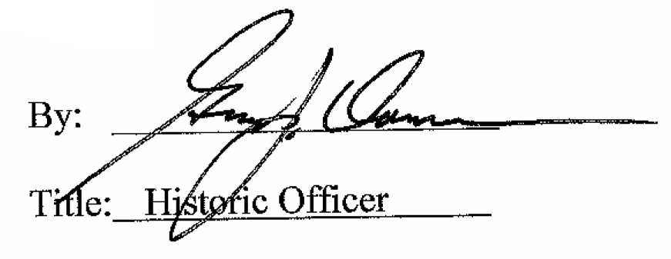

Date of Meeting: May 4, 2016

